# Diabetes Classification Results using GradientBoosting

## Classification Report:

precision recall f1-score support  
  
 0 0.81 0.77 0.79 153  
 1 0.77 0.82 0.79 147  
  
 accuracy 0.79 300  
 macro avg 0.79 0.79 0.79 300  
weighted avg 0.79 0.79 0.79 300

## ROC AUC Score:

ROC AUC Score (GradientBoosting): 0.8495842781557067

## ROC Curve:

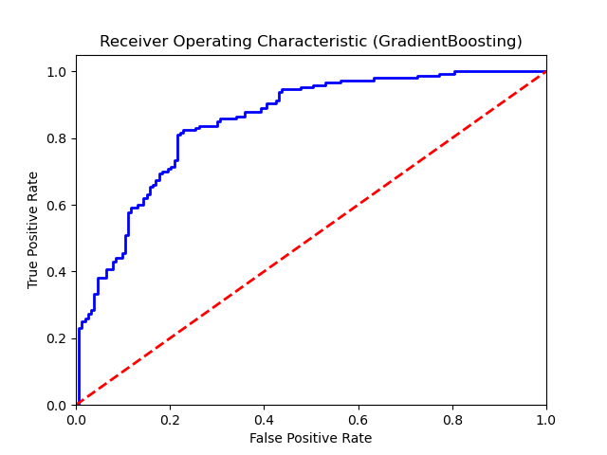

## Confusion Matrix:

True Negatives: 118

False Positives: 35

False Negatives: 27

True Positives: 120

## Confusion Matrix Plot:

